**University of Petroleum and Energy Studies**

School of Computer Science

Department of Cybernetics

**Graphics & Animation Tools**

**LAB FILE**

**(Session: 2020-2021)**

Course: B. Tech with Specialization in Open Source and Open Standards

Submitted To- Submitted By-

Dr. Durgansh Sharma Kunal Ojha

Associate Professor SAP ID -500063333

Department of Cybernetics Roll No. -R100217034

**Experiment 9-** Design of 3D building using Blender.

Google Drive Link- <https://drive.google.com/drive/folders/1nkncC7rBRvgp7xFimE-QuXZnfPuDXWNy?usp=sharing>

Step 1- Open blender and select new file type as general

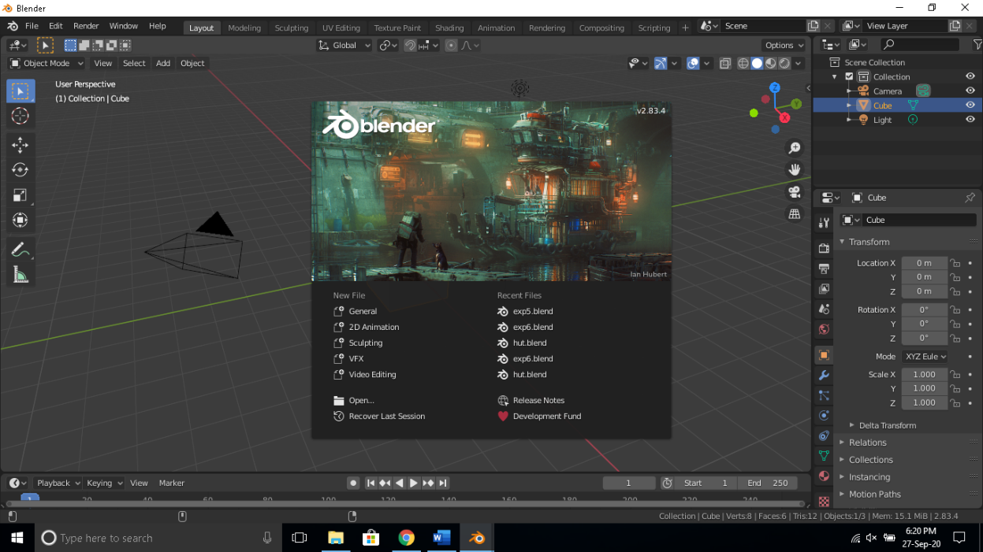

Step 2- Add a cube mesh to the workspace and resize it to make it look as follows-

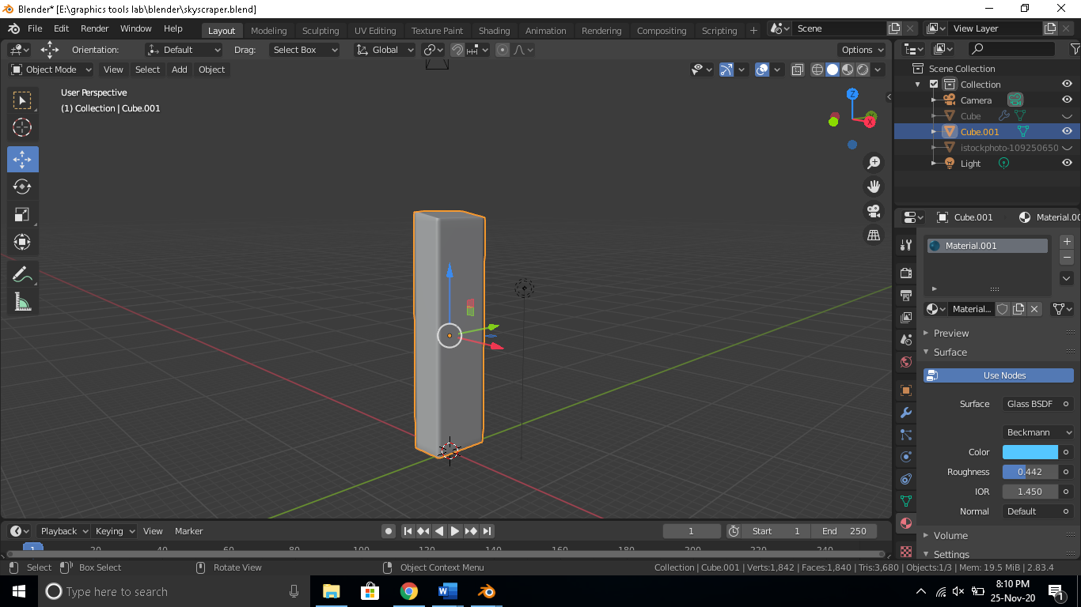

Step 3-Add loop cuts across the cube to make the mesh look like as follows-

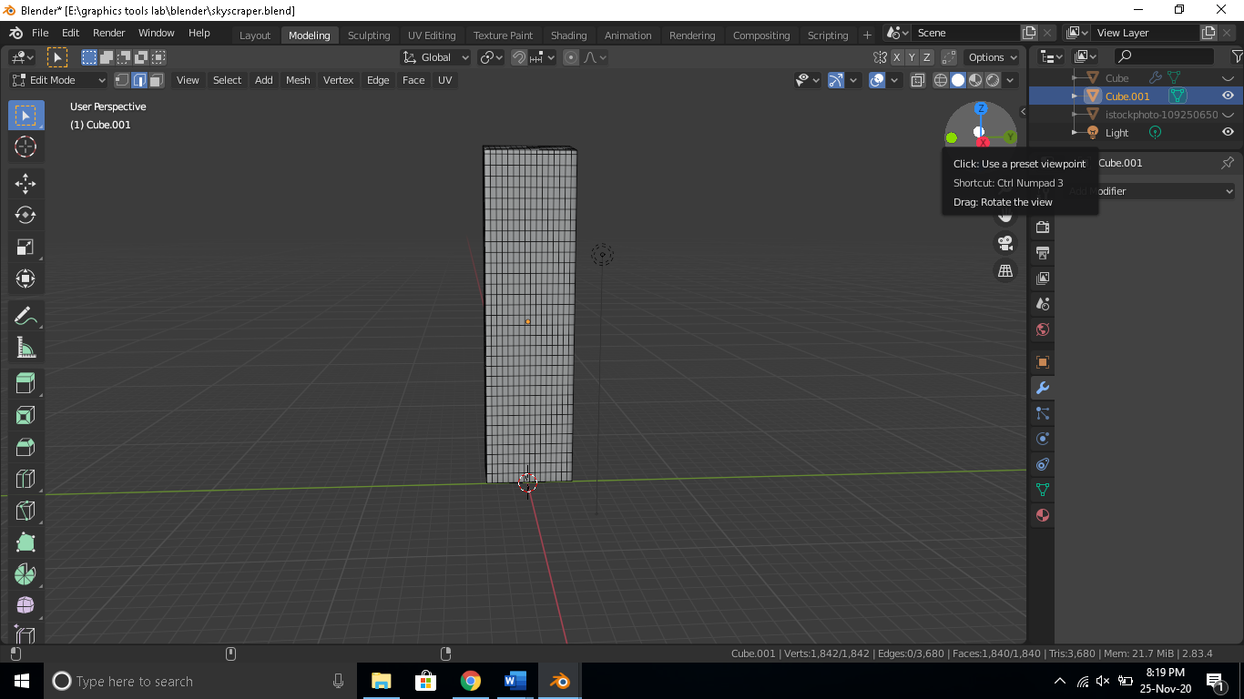

Step 4- Now turn this structure into a wireframe to get the structure as shown in image and add a copy of the cube mesh to fill the spaces the following structure will be obtained.

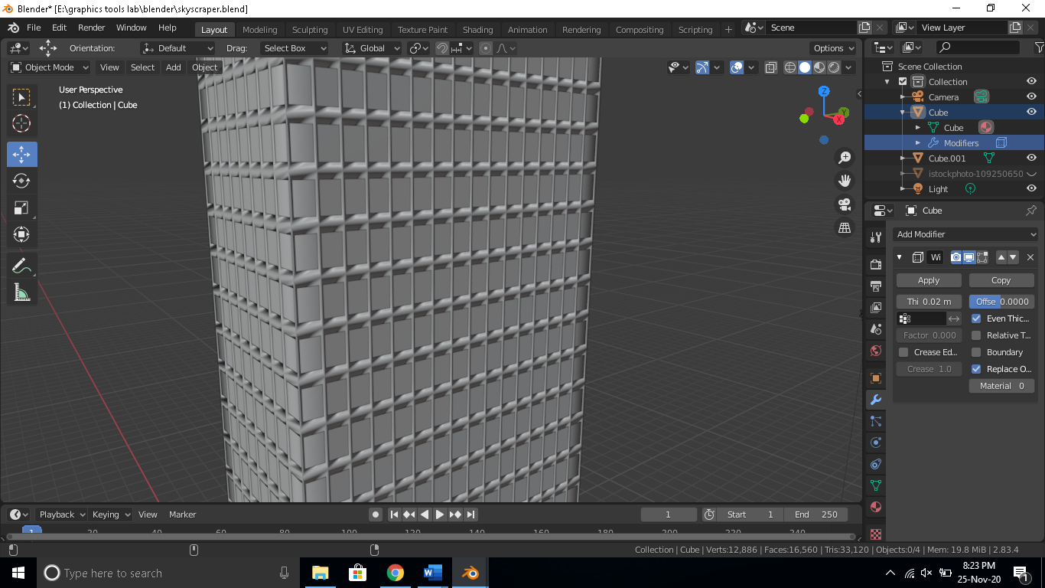

Step 5- Modify the structure based on requirements to obtain the desired structure also you can add other meshes to design other structures of the building. Add color and glass material to make the structure look like an actual building as follows-

